Case 6-Afr-Benin-Trophy Head-Female-19th c

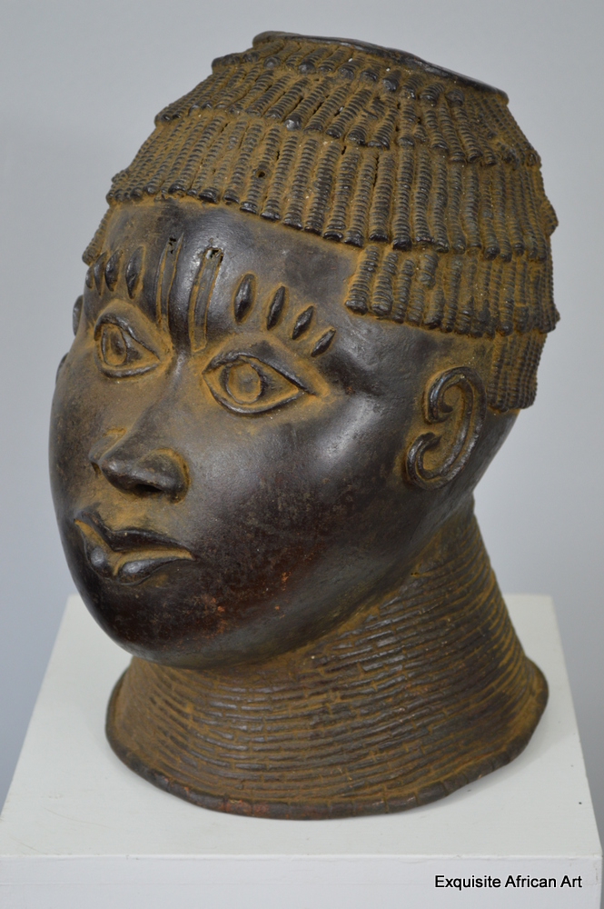

**Case No.: 6**

**Accession Number:**

**Formal Label:**

**Four Keloids above each eye crest and two scarifications above the nasal septum identify this high-ranking princess who was taken in battle.**

**Display Description:**

**LC Classification:**

**Date or Time Horizon:**

**Geographical Area:**

**Map:**

**GPS Coordinates:**

**Cultural Affiliation:**

**Medium:**

This stunning Benin bronze trophy head has been made using the traditional lost wax method.

**Dimensions**: 31 tall x 19 wide x 24 depth  
**Weight:** 4.2kg

**Provenance:**

AP: £1250.00